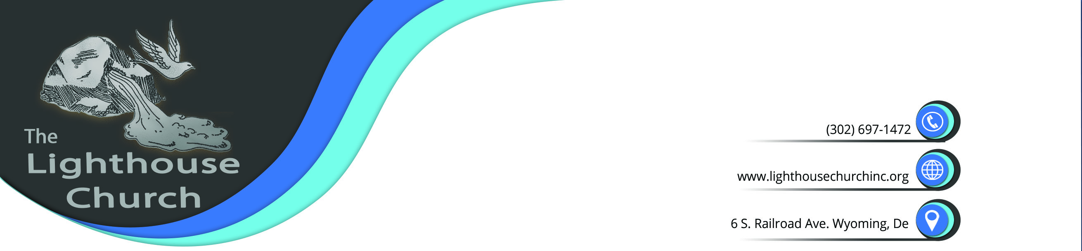

December 31, 2016

Greetings:

This time tomorrow we will have entered into the year 2017. God has spoken and commanded His Body to leave 2016 and all its baggage behind and enter into 2017 free from all those weights that kept His Body weighed down.

My Question:
Did you obey the voice of the Father? If so, then you can look back into 2016 and understand that everything the Body of Christ went through was to grow us up into the full stature of Jesus Christ and become a strong pillar that others can lean on. We have been leaning on the bosom of the Father for quite some time now and now is the time He is releasing us to go forth and complete His complete will for our lives.

If you take a look back at 2016, you will see where the enemy brought up out of hell all he had to destroy the Body of Christ; but if you really look deep into this activity of the darkness; you will have to admit that there was always a glimmer of light there to lead us out of the darkness.
Did we come out unscathed? Absolutely not! The enemy was not playing; he was about his business and his business is stated in John 10:10 (NKJV) 10 The thief does not come except to steal, and to kill, and to destroy. Many left the church because they could not stand the fire. Yes, the fire was raging; but so was our Father’s Power and Authority He gave to His Beloved Ones.

Many times I would have gathered you to My Bosom; but you were too busy running in total fear from the enemy. Does not My Word tell you that the enemy has no power; except the power you give to him? Many of My Beloved ones suffered much from the hand of the darkness; simply because they did not apply all their weapons of warfare that are in My Word.

But that was yesterday and this is today and little ones; you are more than conquerors through My Son Jesus. Stand your ground in 2017 and give no place to the evil one. Take a stand and stand like never before; for this is VICTORY year and JUBILEE has come to My Body of Believers.

Beloved ones in Christ, I admonish you to listen to what the Father has to say. We are truly being blessed in 2017 and God’s promises are yes and amen. God gets all the Glory; whether we rise or whether we fall. He has given us His promises and they are yes and amen. All we have to do is stand on them.


Another question—Will you be the first to say Here I AM Lord Use Me all over again and this time step up to the plate; take up your cross and finish the race that has been set before you?

